
East West University
Department of Computer Science and Engineering

Course code: CSE251; Course name: Electronic Circuits
Experiment no.: 1
Title: I-V Characteristics and Modeling of Forward Conduction of a Diode

Objectives:
- To measure the I-V characteristics of forward conduction of a p-n junction diode.
- To determine the models of forward conduction of a p-n junction diode.

Introduction:
Diode is one of the most basic non-linear electronic devices. An ideal diode acts like a switch for electric current, acting as a short circuit for current flow in one direction (forward bias connection) while behaving as an open circuit for current flow in the opposite direction (reverse bias connection). The characteristics of practical diodes are however somewhat different from those of ideal ones. The p-n junction diodes are one of the most popular types of diodes used in the industry. The forward bias current-voltage (I-V) characteristic of a p-n junction diode will be measured in this experiment.

Circuit Diagram:
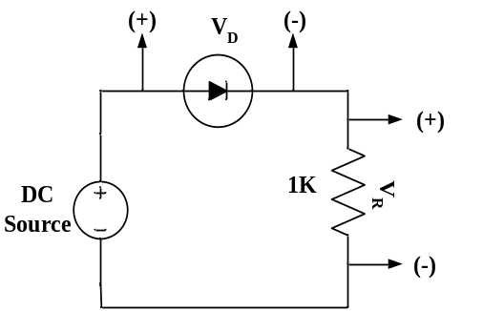
Figure 1. Circuit set up to measure forward bias I-V characteristics of a diode.

Equipments and Components Needed:
- DC power supply
- Digital multimeter
- Diode (1 pc)
- Resistor 1KΩ
- Breadboard
- Connecting wires

Lab Procedure:
- Measure the resistance value of Figure 1 with the multimeter and write it down in KΩ in Table 1.
- Connect the circuit as shown in Figure 1. Use the DC power supply unit as DC source.
- Change the DC source and measure the values of V_{D} and V_{R} and write them in Table 1. Continue measurement until V_{D} reaches to around 0.68 volts. Take around 25 to 30 readings by increasing the DC power supply with an increment of ≈ 0.5 V after V_{D} reaches to around 0.68 volts.
- Divide V_{R} by the measured value of resistance in KΩ. This is diode current I_{D} in mA.

Table 1. Experimental Datasheet.
V_{D} (V) | V_{R} (V) | I_{D} (mA) = V_{R}/R(KΩ) | Measured Value of R (KΩ)
1.
35.

- Have the datasheet signed by your instructor.

Post-Lab Report Questions:
- Using MATLAB, plot the I-V characteristics of the p-n junction diode in forward conduction. Label the axes appropriately and have it printed.
- Use pencil to identify the points on your graph that are corresponding to I_{D} = 2 mA and I_{D} = 2.5 mA. Use these data points to calculate the diode parameters 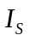 and from the equation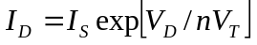. Use V_{T} = 0.0259V.
- Determine the cut-in voltage from the printed graph by drawing extrapolated line with pencil.
- If the diode resistance for the piecewise linear model is defined as , calculate the value of 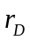 from the data points corresponding to I_{D} = 2 mA and I_{D} = 2.5 mA.
- Simulate the circuit of Figure 1 for a DC bias (V_{S}) range of 0-5 volts using PSpice. Print the I_{D} vs. V_{S} and V_{D} vs. V_{S} plots generated by PSpice and attach them with your report. For simulation, use the DC SWEEP option of PSpice and the diode D1N4148. To modify the diode parameters, select the diode (it will turn red) and go to Edit→Model→Edit Instance Model (Text). There, replace the values of I_{S}, N, V_{j} by your values calculated in steps 2 and 3 and click OK.

